made by: Victor Ramos

Employees.csv: here comes the data of your employees. 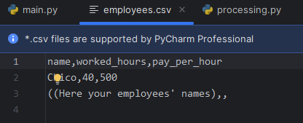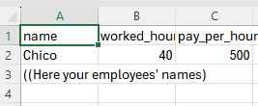

Make sure to save it before running the script (main.py)

processing.py: here are the functions that contain the operations for the gross salary, deductions and net salary. 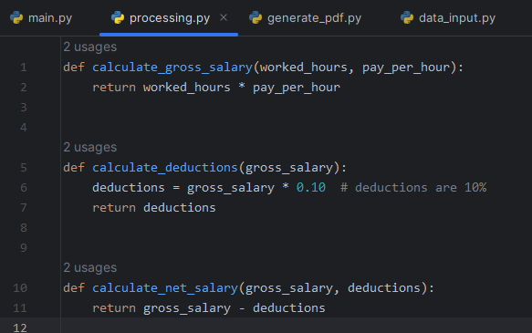

data_input.py: here are two functions. First, we import csv to work on that. Then the read_data function reads data from the CSV file specified in the file_path. It then returns the list of employee dictionaries.   
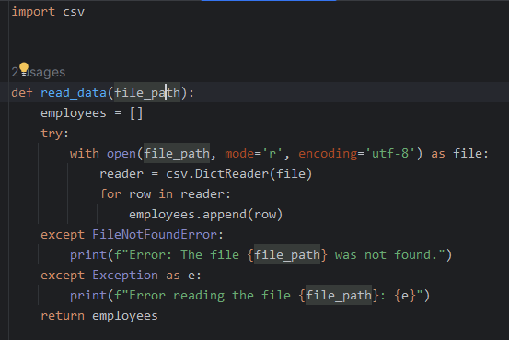

The second function validate_data(employees) takes a list of employee dictionaries from read_data and it validates the employee data. Then, the data is added to the valid_employees list and returns the list of valid employee dictionaries.

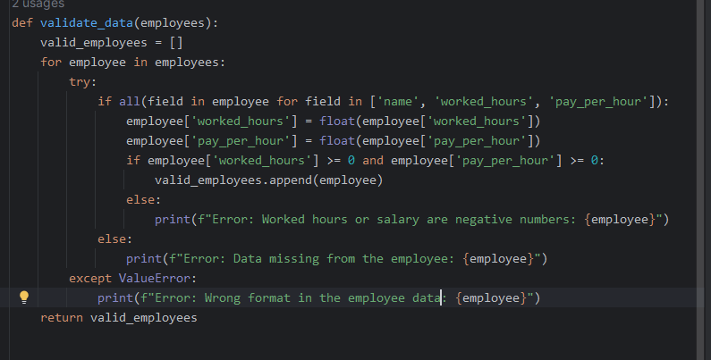

generate_pdf.py: in this file we first import some methods from the reportlab library. Then we create a function which starts by creating a PDF receipt for an employee according to its name and removes it if it already exists. 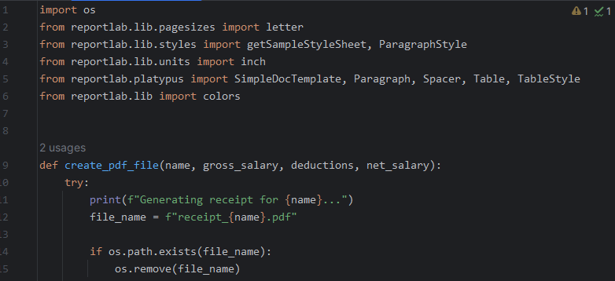

Then in the same function we add some styling for the PDF generated.

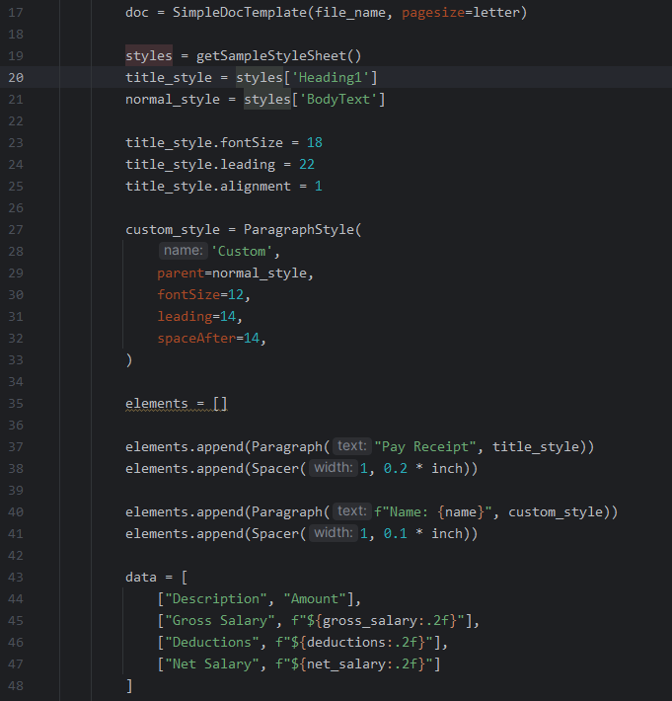

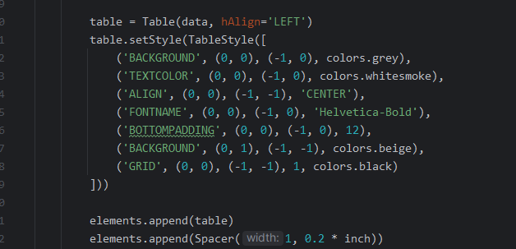

At the end of the file, the method doc.build(elements) generates the final PDF with the style we decided.

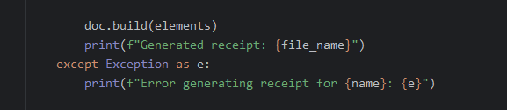

main.py: here is the main function that will execute all the files and functions within the program. You first import the functions from the files and create the main function. first you add your filepath then the script checks if the file exists. If not, it prints an error message.   
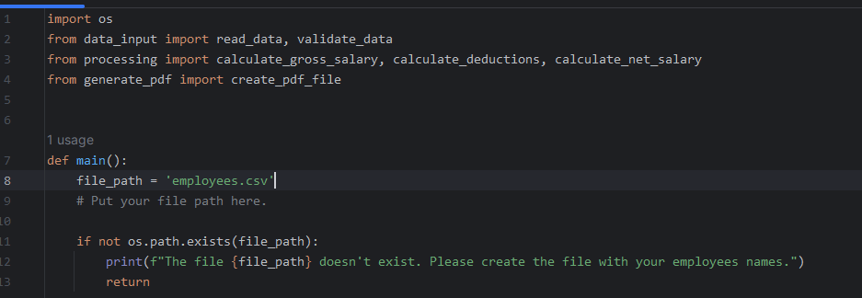

Then the script reads the data from your csv using the read_data function. Then a for loop is created to calculate the gross salary, deductions, and net salary. Then it prints them. At the end of the file the create_pdf_file function is executed to create the file with the data, and the main function is executed. 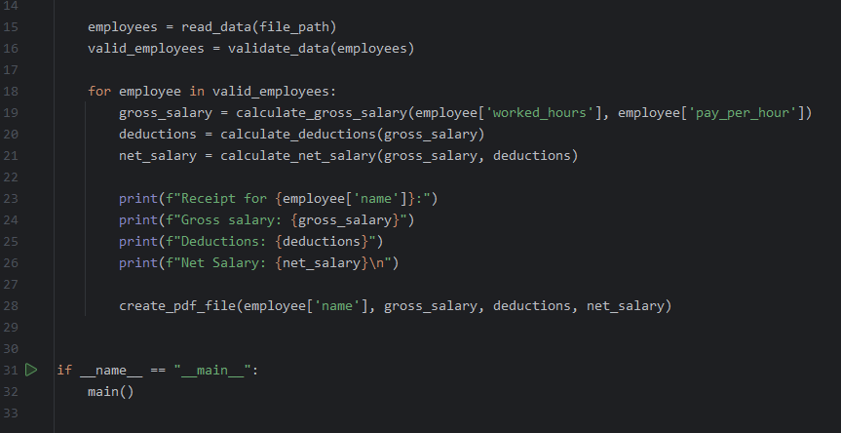

Greetings!